Registration of Players
1

Member Association: SINGAPORE

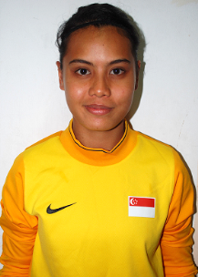 | Name (as in Passport): | NOOR KUSUMAWATI BINTE MOHAMMAD
 |  | ROSMAN
 | Name on Jersey: | WATI
 | Passport Number: | E1932143D
 | Date of Birth: | 29 SEPTEMBER 1990
 | Playing Position: | GOALKEEPER
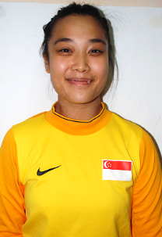 | Name (as in Passport): | SHAHIRAH BINTE JAMIL
 | Name on Jersey: | SHAHIRAH
 | Passport Number: | E1614724K
 | Date of Birth: | 12 JUNE 1992
 | Playing Position: | GOALKEEPER
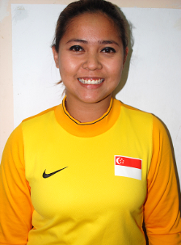 | Name (as in Passport): | NUR FADHILAH BINTI HASSAN
 | Name on Jersey: | FAD
 | Passport Number: | E3002738F
 | Date of Birth: | 06 MAY 1998
 | Playing Position: | GOALKEEPER
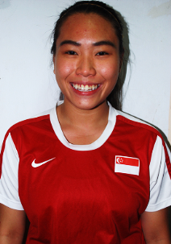 | Name (as in Passport): | LEE LAI KUAN
 | Name on Jersey: | LAI KUAN
 | Passport Number: | E3330657N
 | Date of Birth: | 30 MAY 1994
 | Playing Position: | DEFENDER

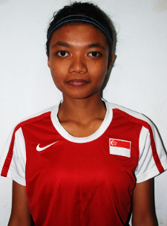 | Name (as in Passport): | NUR ANIQAH IMANA BINTE AZMAN
 | Name on Jersey: | ANIQAH
 | Passport Number: | E2574383L
 | Date of Birth: | 31 MAY 1991
 | Playing Position: | DEFENDER
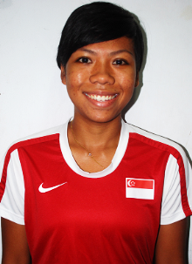 | Name (as in Passport): | HAMIZAH BINTE ABDUL TALIB
 | Name on Jersey: | HAMIZAH
 | Passport Number: | E0908096N
 | Date of Birth: | 02 JUNE 1990
 | Playing Position: | DEFENDER
 | Name (as in Passport): | ROSZIEVA BINTE ROSLAN
 | Name on Jersey: | ROSZIEVA
 | Passport Number: | E1195430F
 | Date of Birth: | 03 JANUARY 1995
 | Playing Position: | DEFENDER
 | Name (as in Passport): | NUR NADIAH BINTE MOHAMAD JAMIL
 | Name on Jersey: | NADIAH
 | Passport Number: | E0773084C
 | Date of Birth: | 22 AUGUST 1991
 | Playing Position: | MIDFIELDER
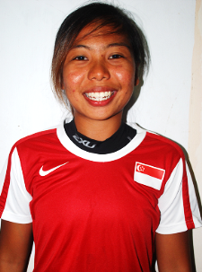 | Name (as in Passport): | ERNIE SULASTRI BINTE SONTARIL
 | Name on Jersey: | ERNIE
 | Passport Number: | E0413197C
 | Date of Birth: | 24 NOVEMBER 1988
 | Playing Position: | MIDFIELDER

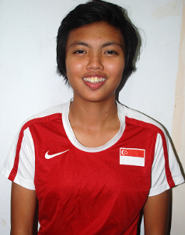 | Name (as in Passport): | SITI NURHIDAYAH BINTE ABDUL MAJID
 | Name on Jersey: | HIDAYAH
 | Passport Number: | E1610266L
 | Date of Birth: | 26 JUNE 1993
 | Playing Position: | MIDFIELDER
 | Name (as in Passport): | CHAN YIN LENG CHERYL
 | Name on Jersey: | CHERYL
 | Passport Number: | E1014097F
 | Date of Birth: | 30 MARCH 1994
 | Playing Position: | MIDFIELDER
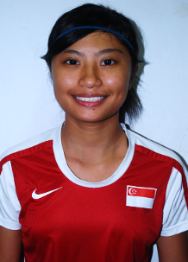 | Name (as in Passport): | NOOR FATIN AFIQAH BINTE NOOR AZIZ
 | Name on Jersey: | FATIN
 | Passport Number: | E1952428L
 | Date of Birth: | 06 MARCH 1994
 | Playing Position: | FORWARD
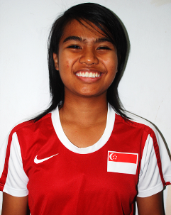 | Name (as in Passport): | SITIANIWATI BINTE ROSIELIN
 | Name on Jersey: | SITI
 | Passport Number: | E1750235J
 | Date of Birth: | 26 MAY 1997
 | Playing Position: | MIDFIELDER
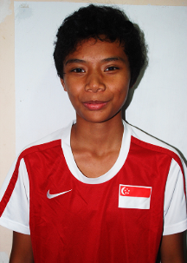 | Name (as in Passport): | SITI ROSNANI BINTE AZMAN
 | Name on Jersey: | NANI
 | Passport Number: | E0797059C
 | Date of Birth: | 22 MAY 1997
 | Playing Position: | DEFENDER

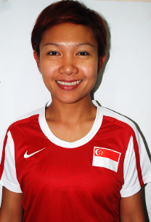 | Name (as in Passport): | SHIDA SHARIFF BAKER
 | Name on Jersey: | BAKER
 | Passport Number: | E1843886L
 | Date of Birth: | 05 JULY 1980
 | Playing Position: | DEFENDER
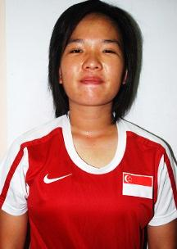 | Name (as in Passport): | CHUA KAI YI ANGELINE
 | Name on Jersey: | ANGELINE
 | Passport Number: | E2940468J
 | Date of Birth: | 07 NOVEMBER 1988
 | Playing Position: | MIDFIELDER
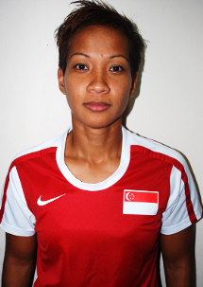 | Name (as in Passport): | ELLY YANTI BINTE ISNAIN
 | Name on Jersey: | ELLY
 | Passport Number: | E2078841L
 | Date of Birth: | 17 OCTOBER 1979
 | Playing Position: | MIDFIELDER
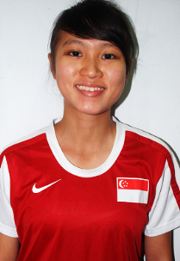 | Name (as in Passport): | HO HUI XIN
 | Name on Jersey: | HUI XIN
 | Passport Number: | E3127262K
 | Date of Birth: | 23 APRIL 1992
 | Playing Position: | MIDFIELDER
 | Name (as in Passport): | ONG KAI XUAN KIYOKO (WANG KAIXUAN)
 | Name on Jersey: | KIYOKO
 | Passport Number: | E2238549D
 | Date of Birth: | 08 JUNE 1988
 | Playing Position: | DEFENDER

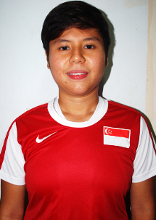 | Name (as in Passport): | ENG YAN RAN VIVIAN
 | Name on Jersey: | VIVIAN
 | Passport Number: | E2046963A
 | Date of Birth: | 25 MARCH 1989
 | Playing Position: | FORWARD
 | Name (as in Passport): | NUR AZIMA BINTE AHMAD
 | Name on Jersey: | AZIMA
 | Passport Number: | E2241952F
 | Date of Birth: | 01 AUGUST 1993
 | Playing Position: | MIDFIELDER
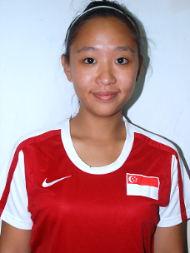 | Name (as in Passport): | CHUA CHU YI ANNE MARIE
 | Name on Jersey: | ANNE
 | Passport Number: | S9231889C
 | Date of Birth: | 05 SEPTEMBER 1992
 | Playing Position: | MIDFIELDER
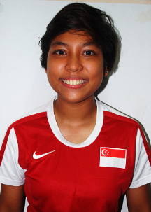 | Name (as in Passport): | NUR EMILIAH BINTE HAZALI
 | Name on Jersey: | EMILIAH
 | Passport Number: | E1110835L
 | Date of Birth: | 16 JUNE 1992
 | Playing Position: | DEFENDER
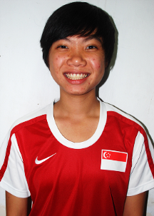 | Name (as in Passport): | VALERIE NG HAO YI
 | Name on Jersey: | VALERIE
 | Passport Number: | E1475739J
 | Date of Birth: | 15 SEPTEMBER 1994
 | Playing Position: | DEFENDER

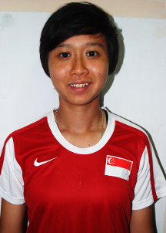 | Name (as in Passport): | NUR IZYANI BINTE NOORGHANI
 | Name on Jersey: | IZYANI
 | Passport Number: | E0862628D
 | Date of Birth: | 02 OCTOBER 1987
 | Playing Position: | DEFENDER
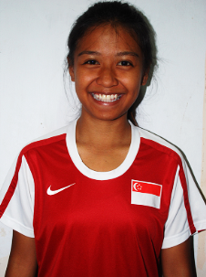 | Name (as in Passport): | SHARIFAH NURATUHASIKIN BINTE ANUAR
 | Name on Jersey: | IKIN
 | Passport Number: | E1858313C
 | Date of Birth: | 27 AUGUST 1992
 | Playing Position: | MIDFIELD / FORWARD
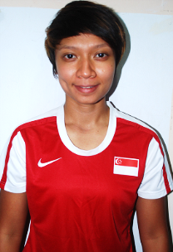 | Name (as in Passport): | KAMALIAH BINTI HASHIM
 | Name on Jersey: | LIA
 | Passport Number: | E1617003F
 | Date of Birth: | 20 APRIL 1990
 | Playing Position: | FORWARD
 | Name (as in Passport): | NABILAH BINTE ABDUL LATIFF
 | Name on Jersey: | NABILAH
 | Passport Number: | E1099141J
 | Date of Birth: | 16 NOVEMBER 1995
 | Playing Position: | MIDFIELDER
 | Name (as in Passport): | NAZARTUL SHEHNAZ BINTE MOHAMMAD REDZUAN
 | Name on Jersey: | NAZARTUL
 | Passport Number: | E2728037B
 | Date of Birth: | 01 MAY 1993
 | Playing Position: | FORWARD

Name (as in Passport):
(Block Letters)
Name on Jersey:
Passport Number:
Date of Birth:
Playing Position:
Name (as in Passport):
(Block Letters)
Name on Jersey:
Passport Number:
Date of Birth:
Playing Position:
Name (as in Passport):
(Block Letters)
Name on Jersey:
Passport Number:
Date of Birth:
Playing Position:
Name (as in Passport):
(Block Letters)
Name on Jersey:
Passport Number:
Date of Birth:
Playing Position:
Name (as in Passport):
(Block Letters)
Name on Jersey:
Passport Number:
Date of Birth:
Playing Position:

Name (as in Passport):
(Block Letters)
Name on Jersey:
Passport Number:
Date of Birth:
Playing Position:

Seal of National Association |  |  | Signature of General Secretary
Date:

Registration of Officials
2

Member Association: SINGAPORE

 | Name (as in Passport): | FOO WEI SHAN SUZANNA
 | Position in M ember Association: | EXECUTIVE TECHNICAL DEPARTMENT
 | Position in Team: | TEAM MANAGER / MEDIA OFFICER
 | Nationality: | SINGAPOREAN
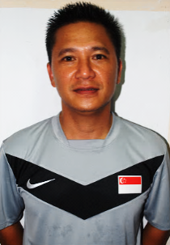 | Name (as in Passport): | MOHAMAD HISHAM BIN ROSLAN
 | Position in Member Association: | COACH
 | Position in Team: | HEAD COACH
 | Nationality: | SINGAPOREAN
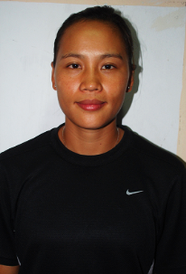 | Name (as in Passport): | CHEN CAIYING
 | Position in Member Association: | COACH
 | Position in Team: | ASSISTANT COACH
 | Nationality: | CHINA
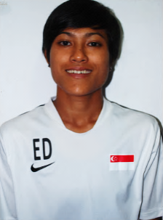 | Name (as in Passport): | ERLINAWATY DEWI BINTE JAFFAR
 | Position in Member Association: | COACH
 | Position in Team: | GOALKEEPER COACH
 | Nationality: | SINGAPOREAN

Registration of Officials

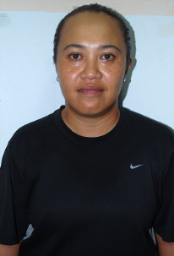 |  | Name (as in Passport): |  |  | ERVIANTI BTE MOHAMED POSARI
 |  | Position in Member Association: |  |  | COACH
 |  | Position in Team: |  |  | ASSISTANT GOALKEEPER COACH
 |  | Nationality: |  |  | SINGAPOREAN
 |  | Name (as in Passport): |  |  | TAN KENG ANN
 |  | Position in Member Association: |  |  | PHYSIOTHERAPIST
 |  | Position in Team: |  |  | PHYSIOTHERAPIST
 |  | Nationality: |  |  | SINGAPOREAN
 |  | Name (as in Passport):
 |  |  |  |  | (Block Letters)
 |  | Position in Member Association:
 |  | Position in Team:
 |  | Nationality:
Seal of National Association |  |  |  | Signature of General Secretary
Date:
To be returned together with the Players Registration Form
Closing date is on 23 August 2012
Closing date is on 23 August 2012

