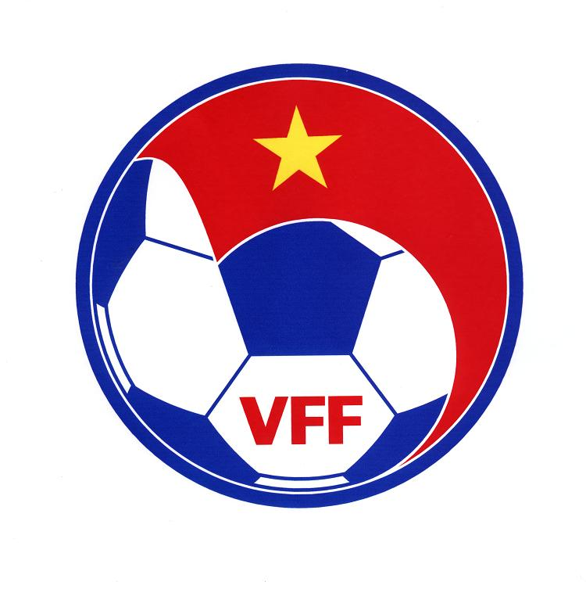

INTERNATIONAL FOOTBALL TOURNAMENT
- VFF CUP 2010
2 November- 6 November 2010 in Hanoi, Vietnam

Rules and regulations

1. NAME, ORGANIZATION AND TITLE SPONSOR:
1.1 The Tournament shall be called “International Football Tournament- VFF Cup 2010”
1.2 The Tournament shall be organized and managed by Vietnam Football Federation (VFF).
2. DATE & VENUE:
2.1 The Tournament will be held from 2 November to 6 November 2010
2.2 Venue: Hanoi, Vietnam
3. PARTICIPANTS
3.1 Participating teams including National teams of DPR Korea, Singapore, Vietnam and U23 Korea Selection team.
4. PRIZE MONEY
Champion : USD 25,000
Runner – up : USD 10,000
3rd placing : USD 5,000
5. TEAM REGISTRATION:
5.1 Preliminary registration of 25 players and 5 officials shall be sent to the Organising Committee Secretariat at least 30 days before the tournament date.
5.2 Participating teams are required to submit a final registration of 20 players from 25 players in the preliminary registration at the end of Team Managers meeting.
5.3 The teams shall be liable to send the following document to the Organising Committee by 2 October 2010 at the latest:
- Name list of officials and players with passport-sized photographs (4cmx6cm)
- A colors team photograph.
- Action photographs of star players
- Team profile (team performance in recent years)
The Organising Committee Secretariat :
Vietnam Football Federation (VFF)
Le Quang Dao Str, My Dinh, Tu Liem- Hanoi, Vietnam
Tel : 84-4-3.7344456
Fax : 84-4-3.8233119

6. REGISTRATION OF COLOURS :
6.1 Two sets of team kit colors and jersey number of players shall be stated at the time of registration.
6.2 Each player shall use the same number as that officially registered throughout the Tournament.
6.3 To avoid clash of colors, the colors of the Teams for all matches shall be determined at the Team Managers’ Meeting.
  - The goalkeepers must wear different colors from the field players

7. MODE OF COMPETITION
7.1 Four teams shall play a single round robin league format .
- Three (3) points for a win
- One (1) point for a draw and
- Zero (0) point for a defeat
7.2 The ranking is determined as follows :
- Greater number of points obtained in all matches
- If there is two or more teams tie on points, after all the matches have been played, the following criteria are applied to determine the rankings :
- goal difference of all the matches
- greater number of goals of all the matches
- greater number of points between the teams concerned
- kick from penalty mark if the two teams concerned are on the field of play.
- Drawing of lots
7.3 The duration of each match shall be 90 minutes divided into 2 halves of 45 minutes each with 15 minutes interval.

8. LAW OF THE GAMES, MATCH OFFICIALS, SUBSTITUTION OF PLAYERS

8.1. All matches shall be played in accordance with the Laws of the Games and its amendments in 2010 as promulgated by the International Football Association Board and published by FIFA
8.2 Not more than five (5) players may be substituted, at any time during a match, from nine (9) reserved players who must be declared before the commencement of each match. A player who has been substituted out can not re-enter the game during the same match.

9. PLAYERS CAUTIONED OR DISMISSED FROM THE FIELD OF PLAY

9.1 A player who received two cautions during the tournament shall automatically be suspended for the match following the match in which he received the second caution.
9.2 A player dismissed from the field of play by a referee shall automatically be suspended for the next match and shall remain suspended until his case has been decided by the Disciplinary Committee.
9.3 A player who do violence to opposing player or match official will be suspended for the whole duration of the tournament and the case will be reported to the concerned confederation.
9.4 More serious cases will be decided by Local Organizing Committee

10. DICIPLINARY COMMITTEE

10.1 Disciplinary committee shall be formed consisting of a Chairman appointed by the Organizing Committee and a representative from each of the participating Teams. If the team of the Chairman of the disciplinary committee is involved, then another Chairman shall be appointed from amongst the other members. No member whose Team is involved may take part in the discussion or vote when the relevant item is being adjudicated. The Chairman shall have the casting vote.
10.2 The Committee shall meet within twenty-four hours of the termination of a match to deal with the following:
10.2.1 Cases of players dismissed from field of play. A player dismissed shall automatically be suspended from taking further part in the Tournament until such time as the disciplinary committee has taken appropriate action.
10.2.2 Any misconduct by an official or player who has been reported to or come under the notice of the Organizing Committee.
10.2.3 A written request or a complaint made by the Management or a participating Team on any disciplinary matter. Such a written request or complaint shall be handed to the secretary of the Organizing Committee within three hours of the incident.
10.2.4 Other case of misconduct which may require disciplinary action.
10.3 The disciplinary committee may only suspend a player from taking further part in the matches of the Tournament. If more severe action is deemed necessary, The national Association to which the player belongs must be informed and any further action shall be the responsibility of such National Association.
10.4 Serious cases of misconduct shall be reported to FIFA and AFC.

11. WALKOVERS, ABANDONED AND CANCELLATION OF MATCHES

11.1 Participating teams shall play every match until they are eliminated
11.2 If, through the fault of any participating team, a match can not take place or be played in its entirely, the Tournament Committee consisting of Chairman of Organising Committee and two other members among the AFC appointed officials shall declare the match to be forfeited (awarding victory and resultant three (3) points for opposing team as well as the score 3-0, or more if the opposing team has already achieved a higher score).
11.3 A match may not be cancelled for sports technical reasons or on account of the venue of weather without first being delayed for a minimum 30 minutes, and if postponed, every effort should be made to reschedule the match for the following day. If it is still impossible to play the match the next day for the same reasons, the match is postponed to a later date.
11.4 If a match of the Tournament is interrupted before the completion of normal playing time of during extra time because of extreme weather or for any reasons outside the control of the Organising Committee, a repeat match lasting 90 minutes shall be arranged for the following day. If it is still impossible to play the match the next day for the same reasons, the match is postponed to a later date.
11.5 All the cases related to withdrawal, walkovers and abandoned matches shall be dealt by the Tournament Committee and no appeals may be lodged against the Committee’ decisions sated in 11.2, 11.3,11.4.

12. APPEAL COMMITTEE

The appeal committee shall comprise a Chairman appointed by the Organizing Committee and a representative from each of the participating Teams. Any protest/appeal must be made in writing to the Chairman, Appeal Committee not later than three hours after the end of match concerned.
The Committee will deal with all appeals, protests, etc. arising from the Tournament. However, the following cases are not subjected to appeals:
  - Warning
  - Reprimand
  - Suspension for less than three matches
All decisions of the Committee shall be final.

13.FINANCIAL ARRANGEMENTS

13.1 The Organising Committee shall provide the following :
13.1.1 AFC officials and foreign referees :
a. Accommodation in a good hotel (4 or 5 stars hotel) – two days before the commencement of the tournament and one day after their last assignment.
b. Suitable meals, three time a day.
c. Return economy class air tickets.
d. - Daily allowance of 100 USD net per day as stipulated by the AFC and an additional 100 USD for miscellaneous (one time only) shall be paid to officials concerned before the completion of the competition.
- Reimbursement of the air tickets (economy class) purchased for the match officials.
- The Officials’ allowance and air fare (if any) shall be settled before their departure. All taxes and fees, if any levied on the allowance and payment made to the Officials shall be borne by the Organizing Committee.

e. Local transportation
13.1.2 Teams :
a. Accommodation in a good hotel to be decided by the Organizing Committee for maximum 25 persons (20 players and 05 officials) from two days before the commencement of the tournament to one day after their last match or otherwise agree by the Organising Committee and Teams by separate agreement.
b. Three meals at a day will be provided and snacks before a game play.
c. Local transportation
d. International Air tickets (economy class for 25 persons)
13.1.3 Local people:
Payment for members of the Organising Committee, the staffs, Vietnamese referees, Asst.referees will be stipulated in the local financial regulations of the Tournament.

13.2 Teams’ financial obligations :
The Organising Committee is not liable for paying any expenses and cost other than those mentioned in 13.1.2 for the foreign participating teams. All the expenses and cost incurred by a participating team (including but not limited to the side of traveling party more than mutual agreed side of delegation between Teams and Organising Committee, services ordered by team itself other than those mentioned in these regulations shall be borne by the participating teams itself.

14. PRESS CONFERENCE :
Right after the completion of each match, the Head coaches of the two teams concerned are responsible to attend the post match conference.

15. FAIRPLAY
In every match of this Competition, Fairplay should be actively promoted.

16. SECURITY

The Organising Committee shall be responsible to provide adequate security arrangements to all participants, officials and referees to prevent the violent incidents. Such security arrangement shall cover the stadium and its vicinity, the training grounds, hotels ect...

17. OFFICIALS REPORTS;
17.1 The referee’s reports together with Forth official’s reports shall be completed and faxed to AFC after completion of each match.
17.2 A detailed statement of accounts showing the gross receipt and amount deducted from Government and/or municipal taxes must be sent to AFC Secretariat within 30 days from the date of completion of the Tournament. Levies payable to FIFA and AFC in accordance with their regulations.
17.3 The AFC Referee Assessment form must be completed by an official in charge of the referees after each match and sent to AFC Secretariat within 24 hours
17.4 The designated Match Commisioner’ report form as well as the Match data sheet including result and cases of caution, expulsion and serious incidents (if any) shall be completed and transmitted to the AFC Secretariat immediately after the match. The completed original form must be posted to the Secretariat afterward.
17.5 The Organising National Association shall send a report of the tournament to the General Secretary of AFC within 30 days of the completion of the tournament. The report may be brief but shall as complete as possible and shall contain the necessary items, such as difficulties met with and the recommendations offered for the benefit of the future tournament.

18. GENERAL PROVISION

18.1 In case of difference of interpretation of these regulations, the Organizing Committee’s decision shall be authoritative.
18.2 The Organizing Committee shall decide on all cases and events not covered by these regulations and its decision shall be final.

THE ORGANIZING COMMITTEE

